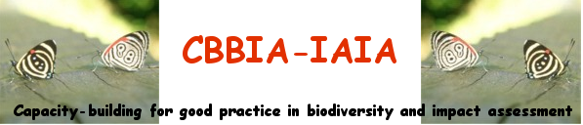

BURSARIES to ATTEND CBBIA MEETINGS

We are seeking applications for bursaries to attend training on biodiversity and impact assessment and on Strategic Environmental Assessment (SEA) from 28 to 30 May 2005, in association with IAIA's 25th annual conference in Boston, USA from 31 May to 3 June 2005.

Suitably qualified people will have a demonstrable interest or professional involvement in biodiversity and/or impact assessment. The bursaries will:
- enable Impact Assessment professionals to strengthen their knowledge of biodiversity issues and concerns, and/or
- enable biodiversity specialists to enhance their understanding of impact assessment tools
- enable planners and decision makers to enhance their understanding of IA as a tool for conservation and sustainable use of biodiversity
- provide students and early career professionals with learning and career-development opportunities.

Key training courses offered by the CBBIA

- Strategic Environmental Assessment (SEA) and Sustainability Appraisal (SA) in Developing Countries
- Mainstreaming Biodiversity in EIA for Improved Environmental Decision Making

Qualifying criteria for CBBIA bursaries

You must be:
- currently studying for a relevant degree, or
- a graduate from a suitable degree course (see appendix A), or
- involved in research on biodiversity, impact assessment or sustainable development, or
- involved in other relevant training (e.g. practical ‘on the job’ training)
- professionally involved in Impact Assessment, biodiversity conservation and planning or development planning

You may be at any stage in your career.

How to apply

Please send applications for bursaries to:

Mr. Napoleon Tiapo,
CBBIA-IAIA Program Administrator,
IAIA International Headquarters
1330 23rd Street S, Suite C,
Fargo, North Dakota, 58103, USA

or by email to:
Project@iaia.org

Your application should specify the following details:

Name
Contact details, including email
Qualifications
Professional/organisational affiliation if any

You should also provide a brief explanation (no more than 1 page) of your interest in biodiversity and impact assessment and how attendance at IAIA meetings would help in your work or training.

Please also include a copy of your CV.

Application Deadline

For applications to be considered, they should be received by the CBBIA-IAIA Program Administrator not later than March 4, 05.

