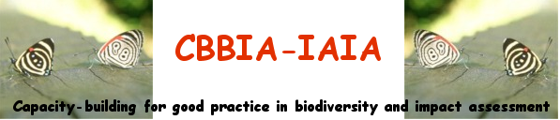

BURSARIES to ATTEND CBBIA MEETINGS

We are seeking applications for bursaries to attend training on biodiversity and impact assessment from 20 to 22 May 2006, in association with IAIA's 26th annual conference in Stavanger, Norway from 23 to 26 May 2006.

Suitably qualified people will have a demonstrable interest or professional involvement in biodiversity and/or impact assessment. The bursaries will:
- enable impact assessment professionals to strengthen their knowledge of biodiversity issues and concerns, and/or
- enable biodiversity specialists to enhance their understanding of impact assessment tools
- enable planners and decision makers to enhance their understanding of IA as a tool for conservation and sustainable use of biodiversity
- provide early career professionals with learning and career-development opportunities

Training course opportunity

One course specific to biodiversity, “Mainstreaming Biodiversity in EIA for Improved Environmental Decision Making,” is being offered at IAIA06. However, bursary recipients can select from any of the pre-conference courses being offered. For more information on each training course, please visit www.iaia.org > Conferences > IAIA06 Main Page, or contact Bridget John (bridget@iaia.org, +1.701.297.7908).

Qualifying criteria for CBBIA bursaries

You must be:
- involved professionally in biodiversity conservation and/or environmental assessment
- in the early stages of your career (five years or less)
- involved or experienced in the energy sector or extractive industries

How to apply

Please send applications for bursaries to:

Mrs. Bridget John
CBBIA-IAIA Program Administrator
IAIA International Headquarters
1330 23rd Street S, Suite C
Fargo, North Dakota, 58103 USA

or by email to:
project@iaia.org

Applications by e-mail should have the following subject line:
Lastname – IAIA06 bursary (Example: Thompson – IAIA06 bursary)

Your application should specify the following details:

Name
Contact details, including email
Qualifications
Professional/organisational affiliation, if any
1st and 2nd choice of IAIA06 training course

You should also provide a brief explanation (no more than 1 page) of your interest in biodiversity and impact assessment and how attendance at IAIA meetings would help in your work or training.

Please also include a copy of your CV.

Application Deadline

For applications to be considered, they should be received by the CBBIA-IAIA Program Administrator not later than 31 January 2006.

