CBBIA SMALL GRANTS PROGRAM
APPLICATION FORM

Application No._____ (CBBIA use)

The conditions relating to Small Grants are detailed in ‘CBBIA Information about Small Grants’, which should be read before the application is completed. The completed form plus should be emailed to CBBIA Project Administrator, Mr. Napoleon Tiapo, IAIA: Project@iaia.org. Alternatively the form can be completed in hard copy, either typewritten, or handwritten in dark ink, and set out clearly in the spaces provided. The application may not exceed the three sides of the form. Please also supply signed supporting statements from two suitably qualified referees.

1. Title of proposal

Monitoring of physical features by means of an automatic weather station (data logger) to assist management with the manipulation of the river mouth and conservation of the Heuningnes estuary and surroundings.

2. Name and address of applicant, and address:

Roelof Jalving
Conservation Manager
De Mond Nature Reserve
P.O. Box 277 Bredasdorp 7280

Telephone number: 028-4251242 / 028-4242910
Fax number: 028-4253708
Email address: deMond@isat.co.za

3. Brief summary of the proposal
Please explain its purpose and relevance to the CBBIA- objectives, the approaches and methods to be used, expected outputs and results

3a Background

The De Mond Nature Reserve was proclaimed a nature reserve in 1986 and is situated between Struisbaai in the West and Waenhuiskrans/Arniston in the East (1000 hectares). The Heuningnes Estuary, which is situated within the De Mond Nature Reserve, extends to approximately 2 km upstream of the Heuningnes River with tidal influences extending up to approximately 12km upstream. It is characterized by strong tidal activity, instability and variability of the estuary banks and inlet channel, clear water with high salinities, and generally a strong influence of the littoral environment (Bickerton, 1984). The reserve is an internationally important RAMSAR site (declared in 1986) containing numerous breeding shorebird species, including the endangered Damara and Caspian tern and the near threatened African black oystercatcher. Currently of a combined total of 250 rivers assessed in terms of conservation importance for the Department Water Affairs and Forestry, the Heuningnes estuary was ranked 25th in South Africa (Turpie et al 2002. The Cape Action Plan for People and the Environment (C.A.P.E.) project ranks the Heuningnes estuary third most important in the Western Cape Province and in dire need of protection (Prochazka & Griffiths, 2000)..

In 1937 Major P van der Byl and Mr. M van Breda (landowners in the district) approached the Minister of Agriculture and Forestry in connection with the driftsand problem at De Mond. Following this, the Secretary for Agriculture and Forestry wrote to the Department of Lands requesting the expropriation of the land adjacent to the mouth of the Heuningnes (Directorate of Forestry, in litt.). Mention was made of the threat posed by the driftsand to the river mouth and the fact that if the river mouth were to become blocked, approximately 24 000 ha of agricultural land would be flooded (Directorate of Forestry, in litt.). In 1939 the Department of Agriculture and Forestry began buying up land around the Heuningnes Estuary with a view to stabilising the driftsands.

Dune reclamation work at De Mond was started by the Department of Forestry in 1942 when a large sand dune moved across the Heuningnes River near its mouth (Walsh, 1968). The mouth of the Heuningnes was kept open by the Department of Forestry until 1973 when it closed. The mouth remained closed for a long time, the bar being breached only by high springtides. The mouth was re-opened during 1976. This action was strongly supported by the local riparian landowners, who were persistent with their demands that this practice be continued, for fear of potential flooding of properties upstream. The situation is typical of riparian ownership, where facilities have been built within the flood-plain of the river system, resulting in natural processes having to be manipulated to accommodate the situation.

Early in 1991, De Mond dune stabilisation programme was terminated. To prevent closure of the mouth, the building of barriers on top of the frontal dunes during neap tides is the only interference with natural ecological processes on the reserve.

Zoetendals vlei is situated 15 kilometres upstream from De Mond Estuary and is the largest fresh water lake in South Africa connected to the sea by the Heuningnes river. It plays an important part in estuarine processes; it supports a large and varied birdlife and is an excellent wildfowl refuge. The lake acts as a silt trap and has a large estuarine fish population.
If water extraction, siltation, eutrophication, pollution a decline in annual rainfall and an incline in salinity are not monitored, it will severely harm the environment and affect the De Mond Estuary detrimentally.
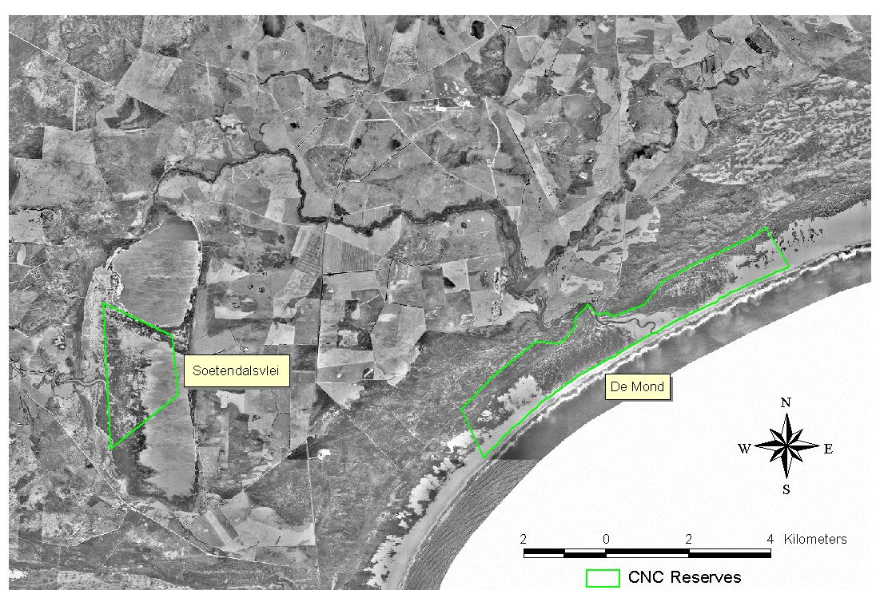

FIGURE 1: Locality of De Mond and Soetendals vlei Nature Reserves

3b Objectives
- To protect the biodiversity of the Heuningnes estuary and safeguard riparian properties upstream.
- To monitor all physical aspects of the Heuningnes estuary, river, Zoetendals vlei and tributaries.
- Make future decisions based on scientific facts and good available monitoring data.
- Climate data can be used in climate change studies.
- Department of Water Affairs and Forestry (DWAF) have a water level recorder installed at the De Mond Nature Reserve. Climate data will be correlated with water level readings.

Summary of proposal, cont. (use this page if necessary)

3c Approaches and methods
- The project will run indefinitely and will be operated by staff working on the reserve.
- All data collected will be downloaded on a computer and be made freely available to all parties interested. Data will especially be important for the Agulhas Biodiversity Initiative (ABI) Conservation Project.
- Weather Station data to be collected will include:
  - Temperature
  - Wind speed
  - Wind direction
  - Relative humidity
  - Rainfall

Data collected will be used by WCNCB staff on a monthly basis when correlations are compiled for breeding birds.

3d Expected outputs and results (clear deliverables should be identified)

- Although rainfall has been measured manually since 1958, important correlation between estuary tides, water temperature and salinity, wind direction, wind intensity (sand movement), temperature, relative humidity and rainfall are not measured which are important indicators regarding climate change.
- To measure and have forewarning of silting up of the estuary and river mouth are important factors regarding the safety of communities living in the L’Agulhas plain and prevention of flooding of arable land concerning the loss of livestock and pastures and associated infrastructure.
- Measure the impact of river mouth manipulation and associated biodiversity. The CSIR will assist in correlating all data on an annual basis and presenting in a report format, with recommendations.
- According to data collected, to predict future problems and be pro-active.
- Climate data is important to assist staff manage disasters such as floods and oil pollution at sea.
- Correlations of climate data with daily seashore bird breeding monitoring programme, (Damara & Caspian Tern, Black Oyster Catchers and White Breasted Cormorants).
- Climate data will assist with wildfire and block-burn planning and management in the Fire Protection Agency, the data will also be used in the compilation of fire reports.

4. Details of costing and funding requirements

Tools and Equipment:
- Weather station (Automatic Data Logger) : R32 000-00
- Laptop : R12 000-00
- Digital Camera : R3 500-00
- Salinity & Temp meter : R15 000-00

Amount sought from the CBBIA project  R62500 ($9615)

5. Names and addresses of two referees: At least one referee should be from a different place of work to the applicant. Referees must send their statements to IAIA before the closing date. Applicants should give the referees details of the proposal.

Prof Leslie Brown (University of South Africa)
Head: Applied Behavioural Ecology & Ecosystem Research Unit
Private Bag X6 Florida 1710
Telephone number: 011-471 2339
Fax number: 011-471 2555
Email address: lrbrown@unisa.ac.za

Miss Laura van Niekerk (CSIR)
P.O. Box 320 Stellenbosch 7599
Telephone number: 021-888 2491
Cellular: 082 820 3339
e-mail address: lvnieker@csir.co.za

6. Details of other applications (with addresses where appropriate), together with sums sought or awarded, for this proposal.

None. Application has been made for a UNISA PhD student to complete a study on this wetland. This equipment would greatly assist this project, funding applications for this PhD project have not included a request for the above mentioned equipment.

7. Brief curriculum vitae (qualifications, employment) for main proposer:

Current employer: CapeNature, December 1988-current.
(Formerly Western Cape Nature Conservation Board)
Student Nature Conservator: Dassen Island
(Marine and Coastal Management)
Chief Nature Conservator: De Hoop Nature Reserve
Conservation Manager: De Mond Nature Reserve

Qualifications:
National Diploma Nature Conservation (1989)

10.Declaration:I certify that the proposal to which this application refers is not supported through any initiatives other than those listed in ‘6’ (above). I confirm that the results of the work undertaken will be the property of the CBBIA. I also confirm my understanding that acceptance of a grant will imply a requirement for the proposed work to comply with the financial, monitoring and evaluation requirements of the CBBIA Program.
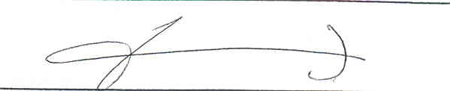
Signature: Date: 29 September 2004

FOR CBBIA USE

Received/Acknowledged | SC: Date / Decision | Amount awarded | Report/due

