
Water, Environment and Forestry Technology

P O Box 320
Stellenbosch, 7599
South Africa
Tel. +27 21 888 2400
Fax +27 21 8882693
www.csir.co.za

27 September 2004

To whom it may concern:

Motivation FOR CBBIA FUNDING FOR HEUNINGNES RIVER ESTUARY

On a national scale the Heuningnes River Estuary is seen as an extremely valuable estuary from a biodiversity and nursery preservative, I therefore fully support the funding application of Western Cape Nature Conservation Board (WCNCB) for additional infrastructure.

The monitoring project being outlined by this proposal is fully aligned with both national and local monitoring/assessment programmes being implemented elsewhere in South Africa. For example, the data that will be collected by WCNCB will be able to inform larger programmes such as Resource Directed Measure studies (Freshwater allocation studies) by the National Department of Water Affairs and Forestry or the C.A.P.E. Regional Estuarine Management Programme funded by Global Environmental Facility.

I have been collaborating with WCNCB for a number of years on the monitoring of estuaries in the Western Cape and have found their staff capable and eager to assist in data collection and evaluation. The only constraint in the past has been the lack of infrastructure. This grant would go a significant way to address this need.

Estuarine management undeniably requires an adaptive management approach, which can only be achieved trough regular monitoring and evaluation. The issues high lighted (e.g. contextual data on weather, climate change, salinity penetration) and the objectives stated (e.g. Determining estuarine health) all relate very well to current scientific thinking with regards to estuarine management in general, and the Heuningnes River Estuary specifically.

I therefore hope that the grant is successful and that WCNCB implement these monitoring procedures as soon as possible.

Sincerely yours
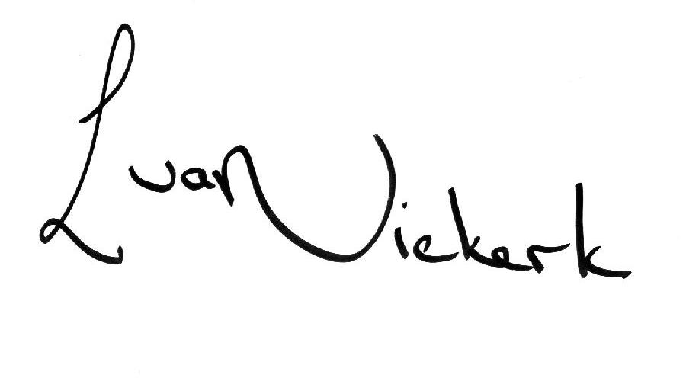

Lara van Niekerk
Estuarine Hydrodynamics and Management
COAST PROGRAMME

