CBBIA SMALL GRANTS PROGRAM
APPLICATION FORM

Application No._____ (CBBIA use)

The conditions relating to Small Grants are detailed in ‘CBBIA Information about Small Grants’, which should be read before the application is completed. The completed form plus should be emailed to CBBIA Project Administrator, Mr. Napoleon Tiapo, IAIA: Project@iaia.org. Alternatively the form can be completed in hard copy, either typewritten, or handwritten in dark ink, and set out clearly in the spaces provided. The application may not exceed the three sides of the form. Please also supply signed supporting statements from two suitably qualified referees.

1. Title of proposal

Using South Africa’s National Bird, the Blue Crane, as a flagship species to assess ecological impacts the current agricultural practices are having on ecosystems in farmlands of the Cape Floral Kingdom.

2. Name and address of applicant, and address:
Vicki Hudson
Blue Crane Field Project Officer
Overberg Crane Group
P.O Box 846
Caledon
7230
Website: www.bluecrane.org.za

Telephone number: 27 82 676-1734

Fax number: 27 28 215-8916

Email address: vickih@global.co.za

3. Brief summary of the proposal
Please explain its purpose and relevance to the CBBIA- objectives, the approaches and methods to be used, expected outputs and results

3a Background

The Blue Crane (Anthropoides Paradisea) is one of the 15 species of cranes – the most endangered bird family on earth. It is found exclusively within South Africa’s borders except for an isolated 50 cranes in Etosha Pan, Namibia. Unlike many of the other crane species it is largely independent of wetlands and found exclusively on privately owned agricultural lands. After a massive decline in numbers in the 1980s (>80%) the species was classified as Critically Endangered under revised IUCN Red List criteria (Cranes: Their biology, husbandry and conservation, Ellis, Gee, Mirande 1996). Reasons for decline included habitat loss, misuse of agrochemicals, powerline collisions and illegal removal from the wild for trade. Blue Cranes historically were found in short natural grassland areas. However with the changing farming practices the farmers in the grain belt of the Overberg and Swartland in the Cape Floral Kingdom unwittingly created an ideal habitat for these cranes during a time when their natural habitat was being destroyed. Of the remaining 22 000 Blue Cranes, more than 12 000 are resident in the Western Cape.

In 1991, high incidents of crane poisonings occurring in the province & subsequent concern from members of the community resulted in the formation of the OVERBERG CRANE GROUP – a non-profit Public Benefit Organisation consisting of a partnership between the local farming community and nature conservation services. A local farmer chairs the group with the steering committee comprises of 2 provincial conservation district officers & ornithologist, 2 farmers and a full time field officer.

Due to the success and conservation of the Blue Crane population in the Western Cape province of South Africa, it is now listed as Vulnerable – IUCN Red List of Threatened Species 2003. Currently it is the only stable to increasing population and is therefore vital in providing answers to the rest of the country as to management of its conservation from a national perspective.

However because the Blue Crane is so interlinked with the ecosystems on farms in the Western Cape the pro has had to broadened its objectives and promote ecologically sound agricultural practices and conserve biodiversity in order to address crane conservation.

The Blue Crane, being so prominent on the farms, is used as a tool towards the introduction of environmental issues to the farmer, farm workers and their children as it is something they are easily able to identify with. Blue Cranes on a farm could indicate environmentally sound farm management or conversely could indicate when things are going wrong in the environment. Because of their striking appearance and size, problems are more readily observed and so by monitoring Blue Crane numbers and investigating mortalities, a number of environmentally unsafe practices and incidents are uncovered.

These have included:
- The misuse of agrochemicals to the detriment of both people and wildlife
- Plastic baling twine pollution of natural veld posing danger to wildlife
- An uneven balance in the predator/prey ratio resulting in domination & decline of certain species over others
- Unacceptably high levels of human disturbance on wildlife.
- Crop stress and damage.
- Quality of life of workers and labour relations on farms.
- Avian Powerline collision threat.

3b Objectives

The objective of this project of the Overberg Crane Group is to introduce the concept of ecologically sound farming practices & ultimately biodiversity conservation using the Blue Crane as a flagship species to farmers their staff and respective families in order to assess impacts on ecosystems on agric lands & to ultimately preserve what we have for future generations.

Summary of proposal, cont.

3c Approaches and methods

By opening channels of communication with the community one is able to introduce the idea of conservation and get feedback on what is happening with species and surrounding ecosystem on the ground.
This can be achieved through:
* Regular farm visits and informal training session.
* Talks in the form of slideshows at farmers meetings, schools, clubs and women’s groups.
* Displays at agricultural shows, tourism centers and farming events e.g. auctions attended in order to network with community.
* Pamphlets and posters handed out at both talks and displays.

The project manager and committee members are actively invited to address audiences from all sectors of the agricultural community on a regular basis with regard to Blue Cranes, their conservation and associated biodiversity
To enhance these presentations a slide projector & tape recorder are used to create an audio and visual impact along with brochures to be used for future references.
Presently this equipment is proving outdated and lacking in efficacy as compared to technology now available. Supplies of printed material have been used up.

3d Expected outputs and results (clear deliverables should be identified)

Records from the past three years show that the Overberg Crane Group have given on average 37 presentations annually to all sectors of the community to audiences ranging from 20 to 1200.

This indicates a minimum annual deliverable output, which can be achieved.

How the Overberg Crane Group feel this proposal fits in with CBBIA Small Grants Objectives and suggested subjects.

The Overberg Crane Group is in need of updated equipment to share information regarding the Blue Crane, its importance in the area as an indicator of the ecosystem and ultimately biodiversity on agricultural lands with the community.
Should the grant be approved it will provide practical support to enable the group to carry out a task requested for by the local people as concerns conservation and ultimately biodiversity.
Through this networking one is able to make stakeholders aware of conservation issues in the area and take it into consideration when assessing impact of agricultural practices & developments.

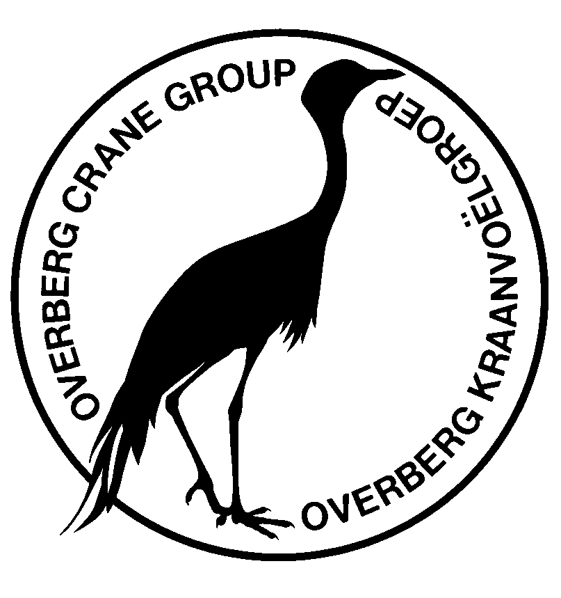

4. Details of costings and funding requirements
Digital Projector = $2770-00
Laptop Computer = $2310-00
Design & Printing of brochure = $1540-00

Amount sought from the CBBIA project  $6620-00

5. Names and addresses of two referees: At least one referee should be from a different place of work to the applicant. Referees must send their statements to IAIA before the closing date. Applicants should give the referees details of the proposal.

Kevin Shaw, Scientific Services, CapeNature.
P/Bag X5014, Stellenbosch 7599
+27 21 866 8000
shawka@cncjnk.wcape.gov.za

Richard Krige, Chairman Overberg Farmers Union.
P.O Box 243, Caledon, 7230
+27 83 414 2391
Boontjieskraal@com2000.co.za

6. Details of other applications (with addresses where appropriate), together with sums sought or awarded, for this proposal.

Overberg Explorer (local community project- chairperson Ann Scott, ecoserve@iway.na) has donated $700-00 towards brochure publication.

7. Brief curriculum vitae (qualifications, employment) for main proposer:

Sr. Vicki Hudson (Dip Vet Verpl)
Diploma Veterinary Nursing – Onderstepoort, SA, 1991.
(2001-present day)
Employed by the Overberg Crane Group as Field Officer through funding from Engen Petroleum.
1998 -2001
Project Manager – Wattled Crane Isolation Rearing Project, Wattled Crane Recovery Programme – South African Crane Working Group & Poison Working Group – Mpumalanga, Endangered Wildlife Trust.

10.Declaration:I certify that the proposal to which this application refers is not supported through any initiatives other than those listed in ‘6’ (above). I confirm that the results of the work undertaken will be the property of the CBBIA. I also confirm my understanding that acceptance of a grant will imply a requirement for the proposed work to comply with the financial, monitoring and evaluation requirements of the CBBIA Program.

Signature: Vicki Hudson Date: 29 September 2004

FOR CBBIA USE

Received/Acknowledged | SC: Date / Decision | Amount awarded | Report/due

