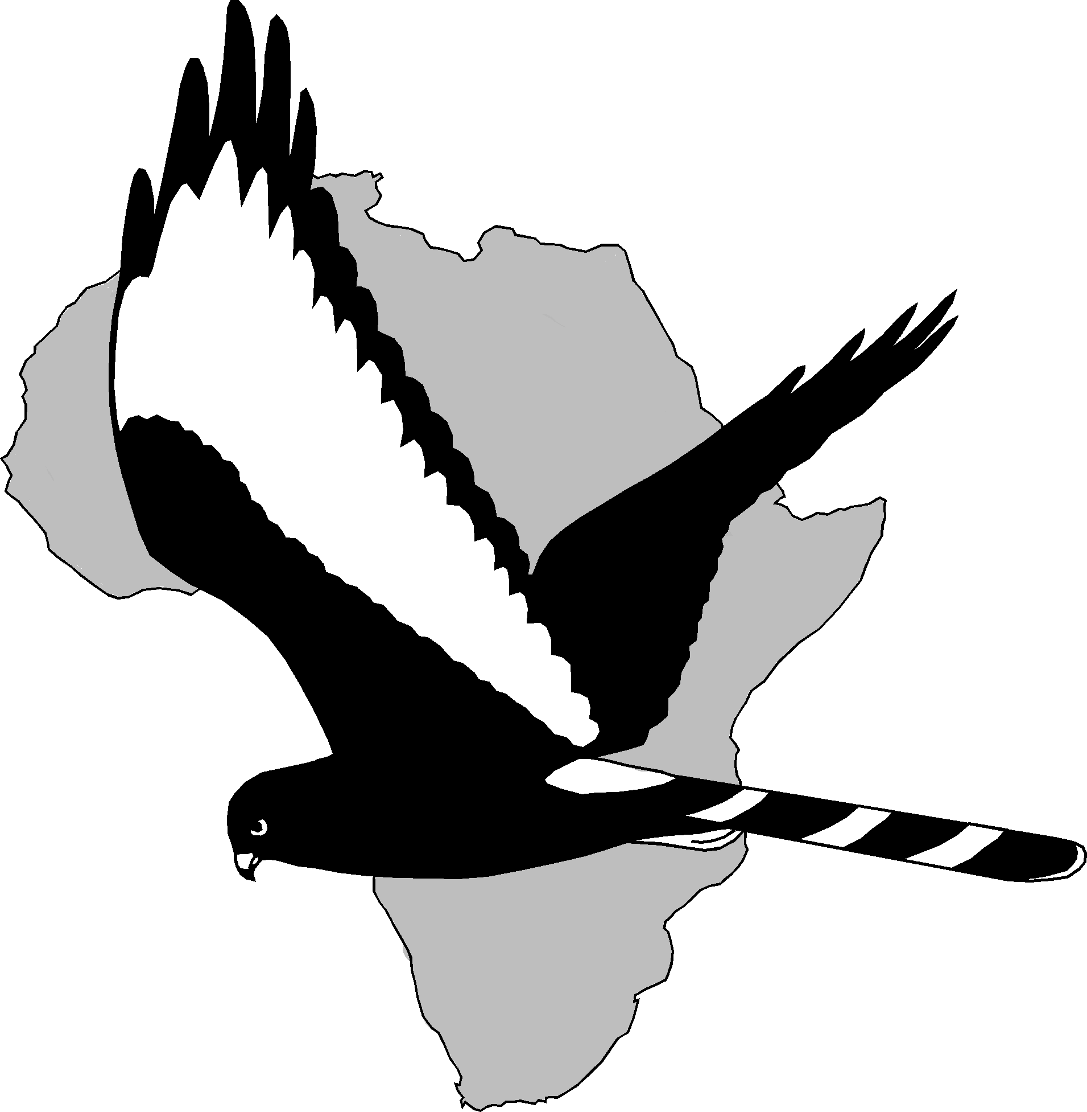UNIVERSITY OF CAPE TOWN
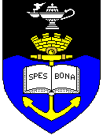
Percy FitzPatrick Institute
of African Ornithology

University of Cape Town
Private Bag, Rondebosch 7701. South Africa
Telephone (021)650-3290/1/7. Messages (021) 650-3290
Fitztitute Fax No.(021) 650-3295
From outside of South Africa replace 021 with 27-21
Internet: http://www. fitzpatrick.uct.ac.za
email: fitz@botzoo.uct.ac.za

Letter in support of funding application:
Impacts of herbivores on the Succulent Karoo vegetation at Anysberg Nature Reserve

The Succulent Karoo is a global biodiversity hotspot with high conservation priority. Anysberg NR, managed by the Western Cape Nature conservation Board, supports significant communities of Succulent Karoo vegetation, and its conservation is one of the key goals of the reserve. Reintroduced game species have the potential to cause damage to the vegetation through overgrazing and trampling, potentially posing a real threat to the smaller endemic succulents. In order to manage these reserves to enhance the persistence of the vegetation, impacts of game species need to be assessed. The project will have a wider currency than just within the reserve, because it will inform decisions regarding general stocking rates of wild ungulates on Succulent Karoo vegetation, an increasingly important issue as commercial farmers look to diversify.

The proposed project is a short-term study, but results will be incorporated into long-term management of the reserve. The study will give an idea of the intensity of animal use in different vegetation types to identify types that suffer most impact. It was the initiated by reserve management and will contribute new knowledge and information for the conservation management of Succulent Karoo. The project results will be disseminated results through both the semi-popular and scientific literature as well as a workshop.

With kind regards

Dr Peter Ryan

