
Water, Environment and Forestry Technology

P O Box 320
Stellenbosch, 7599
South Africa
Tel. +27 21 888 2400
Fax +27 21 8882693
www.csir.co.za

27 September 2004

To whom it may concern:

Motivation FOR CBBIA FUNDING FOR KLEIN RIVER ESTUARY

As the Klein River estuary is extremely important from a national biodiversity preservative and one of the most important nursery estuaries in the Western Cape, I fully support the funding application of Ms G Gail Cleaver, Western Cape Nature Conservation Board(WCNCB).

The monitoring programme being outlined by this proposal is fully aligned with both national and local monitoring/assessment initiatives, e.g. Resource Directed Measure studies by the National Department of Water Affairs and Forestry and the C.A.P.E. Regional Estuarine Management Programme funded by GEF. Therefore data collected in this manner would address future data requirements as stipulated in broad estuarine decisions-making frameworks in South Africa very well, e.g. Freshwater allocation studies (“Reserve”).

I have been collaborating with WCNCB for a number of years on the monitoring of estuaries in the Western Cape and have found there staff capable and eager to assist in data collection and evaluation. In the pass the only stumbling block to this endeavor has been the lack of infrastructure. This grant would go a considerable way in address this need.

Estuarine management definitely requires an adaptive management approach, which can only be achieved trough regular monitoring and evaluation. The issues high lighted (e.g. salinity penetration, berm heights, flushing rates) and the objectives stated (e.g. Determing estuarine health) all relate very well to current scientific thinking with regards to estuarine management in general, and the Klein River Estuary specifically.

I therefore hope that the grant is successful and that WCNCB implement these monitoring procedures as soon as possible.

Sincerely yours
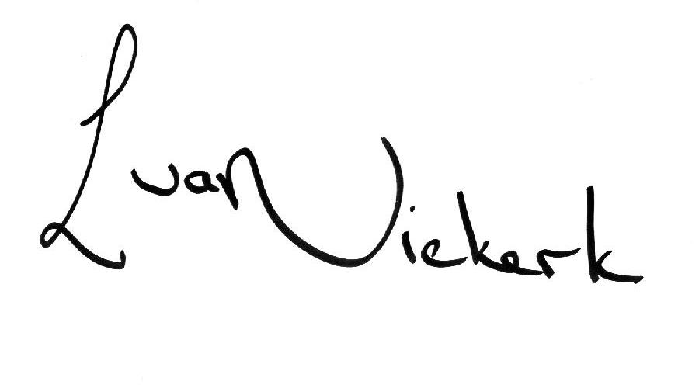

Lara van Niekerk
COAST PROGRAMME

