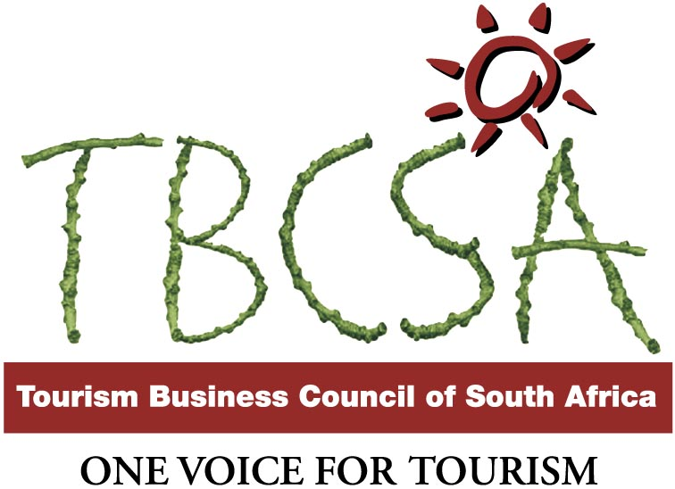

Recommendation Letter
Isayvani Naicker
In Support of her CBBIA Small Grant Application
01.09.04
I have known Isayvani Naicker in her professional capacity as an environmental scientist and practitioner. She is committed to working towards the achievement of broader socio-economic development goals of South Africa and Africa.

In this regards she has an enquiring mind that seeks to analyse, understand and apply knowledge in the field that she practices in with related fields in social and economic areas in a trans-disciplinary manner.

She has contributed at major conferences and made valuable input on the development of the ecosystem approach as a cooperative regional framework for natural resource management in Africa specifically within the Greater Limpopo Transfrontier Conservation Areas (TFCA) in Southern Africa. (a regional integration and collaborative initiative).

Tanya Abrahamse (Dr)
Executive Director
Tourism Business Council of South Africa
+27(0)12 654 7525
exec@tbcsa.org.za

