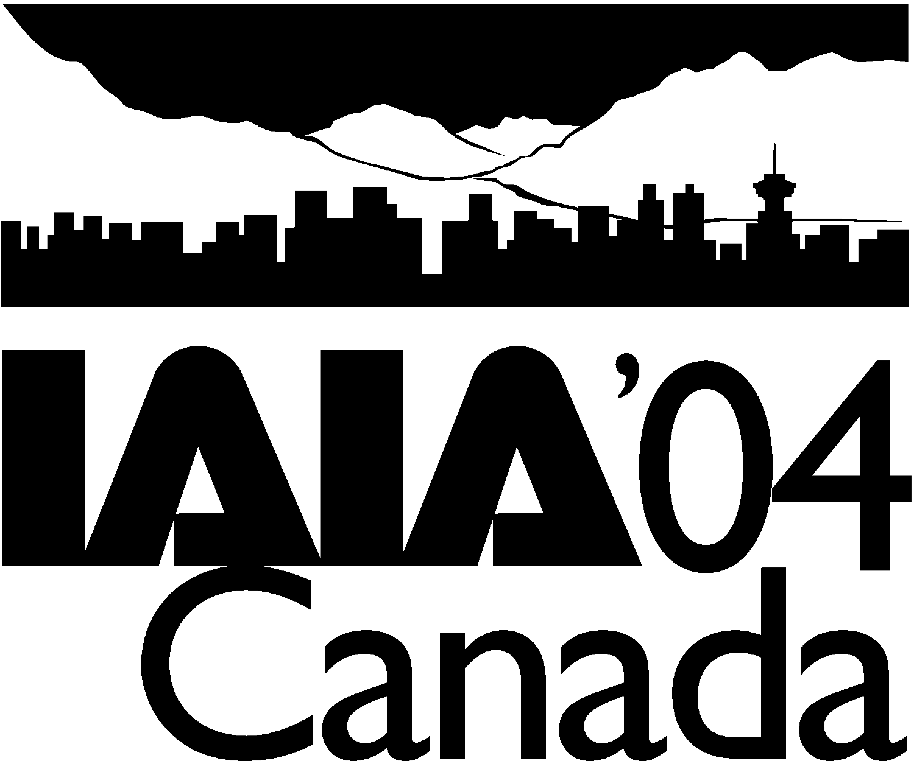 IAIA’04 Update: November 2003

Since the printing of the preliminary program, the IAIA’04 Program Committee has:

- Added two new Theme Forum topics.
- Added one concurrent session.
- Updated the descriptions of three concurrent sessions.

Remember to register early! Early Bird registration rates close 15 December 2003. Convenient online registration is now available.

Two New Theme Forums

Impact Assessment and International Finance
Increasingly, international financial institutions are using the instrument of impact assessment (IA) to manage environmental and social risk on projects they finance. From the multilateral Development Finance Institutions, to export credit agencies, as well as in bi-lateral agreements, including those with OECD countries, impact assessment is becoming integral to prudent project financing.

With the recent promulgation of the Equator Principles, private sector commercial banks are joining up as well. Adoption of the Equator Principles commits a bank to:

- Screen and categorize projects for environmental and social risks.
- Assess social and environmental impacts accordingly.
- Manage potential impacts pro-actively and transparently.
- Covenant environmental and social requirements in loan documentation.

Now, the environmental and social review process established by the International Finance Corporation (IFC -- the private sector arm of the World Bank Group) is being applied to projects around the globe through private sector initiatives. The world has changed.

The Equator Principles work through a hierarchy of requirements, including

- Environmental and social ‘safeguard’ policies.
- Specific, quantitative pollution limits (by industrial sector).
- A transparent public process for their application with impact assessment at the core of the process.

This Theme Forum will be one of the first international events to focus specifically on the use of impact assessment by the international finance community. It will be an important opportunity for international finance and impact assessment practitioners to meet, to share experiences, and to learn how these new initiatives are unfolding.

Topics in this Theme Forum will include the latest information on the application of the Equator Principles; the status and future of the OECD’s “Common Approaches on the Environment,” financial institution processes for implementing IA, integrating IA into financial decision-making, case studies on IA and international finance, the corporate reputational benefits of IA, and IA as a financial risk management tool.

Voluntary Environmental Initiatives - Industry Achievements
Over the past decade, Canadian industry has reduced its ecological footprint and improved the environmental sustainability of its operations. When a company or sector commits to environmental sustainability, it typically commits to adopting best practices and exceeding regulatory standards. As well, it usually concerns itself with the ends of legislation and public policy, ends such as preventing pollution, protecting biodiversity and reducing greenhouse gas emissions. Corporate goals and behaviour are impacted and companies seek out cost-effective risk reduction and win-win opportunities that simultaneously improve environmental and competitive performance.

Impact assessment leading to the mitigation of adverse environmental effects tends to be linked to formal processes and legislation. However, it is becoming apparent that most of the real improvement in industry’s environmental performance is the result of initiatives undertaken voluntarily. This Theme Forum and related concurrent sessions will look at what has been achieved voluntarily through such frameworks and initiatives as Responsible Care (chemicals), Sustainable Forest Management (forest products), Towards Sustainable Mining (mining and metals), Environmental Commitment and Responsibility (electricity) and similar initiatives underway in countries other than Canada. It will look at voluntary industry-government partnerships like the Canadian Industry Program for Energy Conservation (CIPEC) and the U.S. Green Lights Programme. It will examine what drives industry’s participation in these programmes and review what has been achieved.

A number of important questions will be addressed:

- Are some sectors evolving environmentally responsible governance frameworks and moving toward self-regulation as a means of ensuring continued access to resources?
- How successful have various sustainability initiatives and approaches been in engaging large industry and small and medium-sized enterprises, believed to account for about 60% of business pollution and waste?
- How can public policy better support development of voluntary sustainability initiatives?
- How can voluntary sustainability initiatives and frameworks be applied internationally in market economies (Responsible Care programs are now being implemented in more than 40 countries)?

One New Concurrent Session

Linking Impact Assessment and Management Tools
This workshop is intended to build on previous workshops held at Glasgow (1999), The Hague (2002) and Marrakech (2003), and to try to take the topic forward in real terms and in terms of how IAIA can contribute in the field. The workshop is focused on a roundtable discussion based around specific prior poster presentations.
As the concepts associated with sustainable development mature, and new and modified decision aiding tools are developed, so links between environmental (and other impact) assessment and management tools become all the more essential. Increasingly there is experience of trying to make links between tools and across different disciplines, e.g., EIA/SEA and EMS, SEA and CBA, LCA and SEA, SEA and Sustainability Appraisal, etc. The purpose of this workshop, therefore, is to exchange experience through a roundtable discussion based on real examples previously presented to the conference through poster presentations. No papers or other presentations will be considered for this workshop.
Posters (not papers) are therefore invited on the specific workshop theme with the expectation that those posters would form the core of the subsequent roundtable discussion. Posters that clearly fit the theme of linking impact assessment and management tools will be grouped together to be viewed over the first couple of days of the conference. A two-session roundtable discussion workshop (a whole morning or afternoon) will then follow that and will be based on the posters only (no oral presentation, but with one-page versions of the posters circulated). The roundtable would be built around a structured discussion of practical and theoretical issues emerging from the posters, to be structured and convened by the workshop leader. The intention of this workshop is to provide the written benefits of a poster presentation combined with a real forum for discussion on the issues raised by the posters presenters, in a structured but flexible way. Such a discussion is not possible in the usual paper-based workshops. The roundtable discussion would be open to all to contribute, whether a poster had been presented or not, while poster presenters would have the opportunity to share their experience in the context of the discussion.
It is intended that a report from the discussions would be produced, as well as recommendations for further action to promote improved links between tools. If appropriate, the report could be considered for publication in the Journal of Environmental Assessment Policy and Management.

Concurrent Session Updates

Three of the sessions described in the preliminary program have been updated:

- Impact Assessment and NEPAD: Environment, Poverty and Development in Africa
- Industry and CIPEC: Making Progress in Achieving Kyoto Objectives
- Public Participation

We invite you to submit your abstracts on these and other topics before the abstract deadline of 15 January 2004. All abstracts are to be submitted to Jennifer Howell (jen@iaia.org) at IAIA HQ. You can also submit your abstract online.

Presenters must register and pay the registration fees no later than 29 February 2004 to ensure a place on the program.

Impact Assessment and NEPAD: Environment, Poverty and Development In Africa
Recently, certain important initiatives, including the Poverty Reduction Strategy and the New Partnership for the Development of Africa (NEPAD), have been launched on the African continent. It is essential to consider the environmental issues related to those initiatives. In this context, it is important to discuss problems that have been identified in individual impact assessments in individual countries.

Development must take into account the three main types of environmental problems that are affecting the African continent:

- Human health problems (hygiene, parasitic diseases, armed conflict, etc.)
- Degradation of ecosystems and loss of biodiversity
- Global environmental problems (depletion of the ozone layer, climate change)

More than any other region in the world, Africa is affected by the convergence of all three of these types of environmental problems, and by the immense challenges that they pose to its society. Taking environmental factors into account, particularly through the mechanism of impact assessment, can and must play a key role in economic development. This workshop will provide an opportunity to address the major questions concerning impact assessment in relation to those initiatives.

Industry and CIPEC: Making Progress In Achieving Kyoto Objectives
A unique voluntary partnership between Canadian Industry and Natural Resources Canada (NRCan) Office of Energy Efficiency (OEE) and the "Canadian Industry Program for Energy Conservation (CIPEC)" is responsible for promoting voluntary industry participation in reducing Greenhouse Gas (GHG) emissions and energy conservation to assist Canada in achieving its Kyoto objectives. CIPEC industries embrace innovative development, adoption and adaptation of new methods and technologies to meet these objectives. Improved financial performance is often a by-product of these innovations.

Sponsoring the Voluntary Challenge and Industrial Energy Innovators, CIPEC encourages and rewards industry innovations. CIPEC industries use impact assessment to assess, measure, monitor and track atmospheric emissions and energy use. Independent organizations analyze data and publish annual reports charting industry progress in mitigating GHG emissions and conserving energy. CIPEC's success as a unique voluntary partnership between industry and government is of international interest as a model for market economies.

This session will feature presentations from industry sectors, associations and corporations, and discuss:

- How industry uses impact assessment to assess, measure, monitor and track atmospheric emissions and energy use, and the ongoing results.
- CIPEC as a successful model for voluntary industry and government partnerships for international market economies.
- Lessons learned by industry in increased efficiencies and effectiveness which can inform the private impact assessment professional.
- Changing industry roles in impact assessment.

Public Participation
Without informing and involving the public effectively, neither industry and business nor the public sector can hope to prepare valid and reliable impact assessments. This session, building on last year's session in Marrakech, solicits presentations and discussions on:

- Best Practices in Public Participation. Pierre André of the Université de Montréal and Bert Enserink of the Technology University of Delft led a discussion of this subject last year and are preparing a short publication for circulation soon.
- Challenges in Public Participation. This topic generated a lively and productive discussion at the last conference which we would like to continue with the leadership of Profs. André and Enserink.
- Public Consultation in Afghanistan and Iraq: Opportunities, Strategies and Approaches. Are there some lessons to be learned from the departure of the British Raj from India and Africa after World War II? What can we derive from how the British government dealt with "the troubles" in Northern Ireland? What role might third parties play in bridging the gap between the residents and the occupiers fostering trust for national reconstruction? What other ideas are worth exploring to work towards social development and enduring peace?
- Case studies of public participation in impact assessment, especially in the private sector.
- Other papers on capacity building, evaluation, cultural adaptation and other aspects of public participation.

