 Submission of Presentations and Papers

We are requesting presenters to submit their:
- presentations, in PowerPoint format (Note: those using overhead projectors or otherwise not using PowerPoint need not pre-submit presentations)
- papers, in MS Word format (This is optional. It should be done for those who wish to have their papers in the conference publication CD)
by April 15, 2004.

PowerPoint presentations will be organized by session and saved on CDs so the presentations are ready to access during the conference.
PowerPoint presentations and papers will be published in PDF format on a CD-Rom after the conference. If you do not want this to happen, please advise us (at the conference).

For publication on the conference CD, materials must be submitted electronically. They should be submitted as described here, but receipt at the conference is still possible. Submission of a paper is optional. Submission after the conference is over will mean the paper does not get included in the conference CD.

IAIA’04 will provide laptops and projectors in each session room. Overhead projectors will also be available in each room.

Below you will find detailed but very easy instructions on how to submit this material via an FTP site. Please follow these instructions carefully to ensure accurate submission. If you have any questions, please direct them to your Session Chair.

INSTRUCTIONS FOR SUBMISSON
File formats:
Presentations: PowerPoint
Papers: MS WORD

Naming convention:
To name the files you will need the following info:
- Paper abstract number previously provided to you by IAIA (in your preliminary notice of acceptance and final confirmation notice) – this number will start PA followed by 3 numbers (This number is available from your session chair if you get desperate.)
- Last Name of primary author
- Full title of paper

Name the files as follows:
“abstract number” “last name of primary author” “full title of paper”
E.g., The name of my file will be: “Pa107 Ross Common sense in EIA”

Prepare your Power Point files:
When Saving your file be sure to do the following:
In PowerPoint choose “file-save as”
Click “Tools”
Then select “save options”
Then check the: “Embed True Type fonts”
Check the: “Embed all character (best for editing by others)”

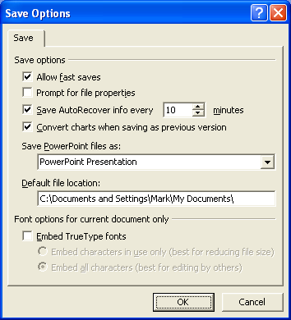

When saving files be sure to check the above box.
This allows all fonts to be saved along with the presentation file.

- Prepare your files: name them appropriately and save them on your desktop.
- Upload your files to the FTP site as follows:

Open your web browser – Internet Explorer. Note that Netscape Navigator cannot gain access to this site. Internet Explorer must be used. Sorry.
In the address box type: ftp.clarksav.com

This will prompt you to enter a login name and password.
Login: iaiapresenter
Password: impact
This will then open a window with two file folders.
- IAIA Papers
- IAIA Presentations
Then drag and drop your files in the appropriate folders.
Close the FTP site and the process is completed.

That’s it -- you’re done. Please complete this by April 15.

